**Akuna 3 Interior Renovation Scope (Revision 1)**

Donna – D

Jan – J

Mike – M

(To design or select or both).

**Ground floor:**

Passage

* Feature cove inset in wall protruding into Ensuite
* Replace light fittings. DJ
* Re tile DJM
* Repaint DJ

.

Bedroom

Replace built in robe incorporating flat screen. DJM

Relocate Floor temp controller to be discreet inside robe door if possible

Wall feature behind bed head. DJ

Replace light fittings DJ

New window covers & curtains DJ

New Carpet DJM

New bed & side tables MJ

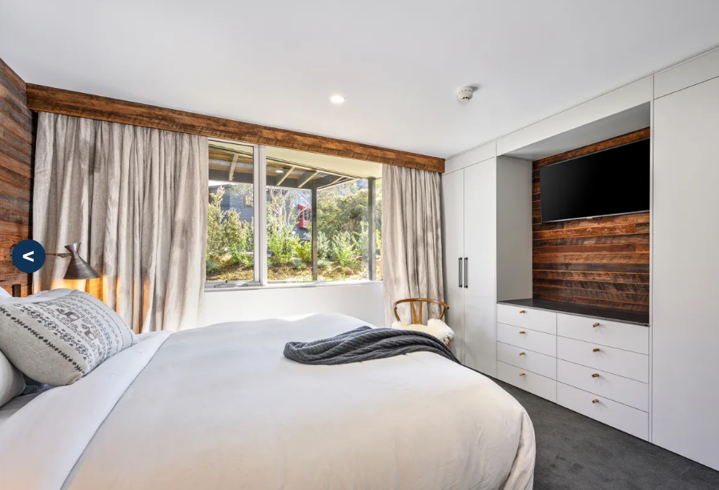

(Bedroom idea mirrored)

Ensuite

Remove all tiles and install/repair under floor heating

Replace shower, glass, Repair/replace water damaged door frame.

Incorporate soap/liquids recess or shelf DJ

Re tile floor and walls. DJ

Replace basin and bench. DJ

Replace mirror DJ

Replace light fittings. DJ

Towel warming rack maybe in place of right end of bench. MJ

Replace toilet. DJM

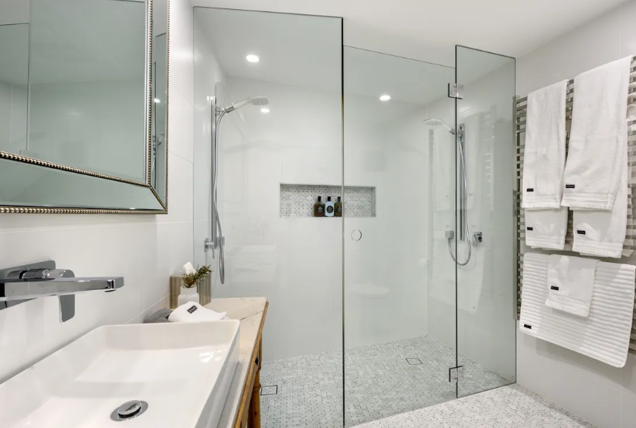

Drying Room

Enlarge room incorporating bench cove area. DM

Retile floor DJ

Install permanent dehumidifier.

Repaint DJ

Laundry

Remove drying cabinet.

Reconfigure layout incorporating broom/cleaning cupboard. DJM

New dryer/washing machine MJ

New light fittings DJ

Retile DJ

Repaint. DJ

Lower Stairway

Remove step grips and replace with continuous carpet mat. DJ

New light fittings DJ

Repaint DJ

**First Level:**

Living/Dining

Replace carpet with Timber or look alike floor DJM

Repair weathered wooden window & doors frames.

Replace gas fire. JM

Box in flue from mantle to ceiling. Roof penetration to remain but Fireplace/chimney can be centralised to wall if desired. DJM

Feature around fireplace to mantle height. Flat screen above mantle. DJM

Possible bench along dining wall to double as dining seats. DJM

New Light Fittings DJ

Repaint DJ

Replace blinds & curtains DJ

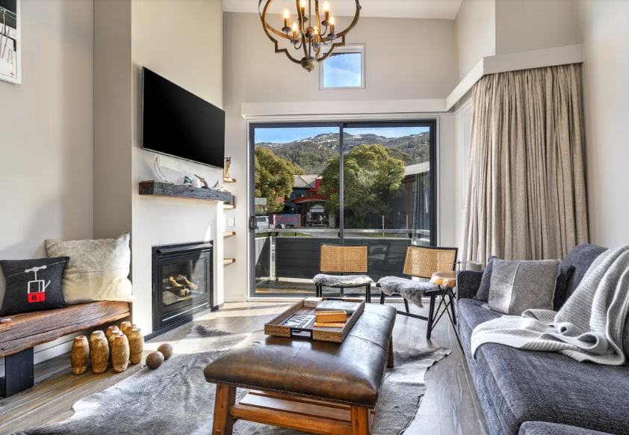

(Living ideas)

Kitchen

Strip out kitchen completely including tiles. Keep new dishwasher. (Stainless front)

Remove floor to ceiling wall at end of bench and possibly the wall beside current fridge position

New design kitchen. Timber or look alike floor. DJM

Built in pantry/broom cupboard or fridge in cove near bathroom entrance. DJM

New Light Fittings DJ

Repaint DJ

Bathroom

Shift door towards kitchen to enlarge cove for pantry or fridge DM

New shower/bath on opposite wall. Incorporate soap/liquids recess or shelf. DJ

Toilet to be replaced in same location. New sink/bench/towel heater on same side DJ

Replace all tiles DJ

Replace mirror DJ

New light fittings DJ

Repaint DJ

Upper Stairway

Tighten steps that squeak.

Possible individual step mats that compliment lower stairs. DJ

New Light Fittings DJ

Repaint DJ

**Loft:**

Balcony wall rails to be removed and wall height raised to 1.1m. DM

Nib wall added for queen bed 1.1m DM

Remove existing storage room door wall. Install Temporary adjacent door and wall as discussed to be removed in future. DM

Repair moisture damage in loft store and possible skirting boards in prep for future carpeting

Carpet throughout. DJ

New light fittings DJ

Repaint. DJ